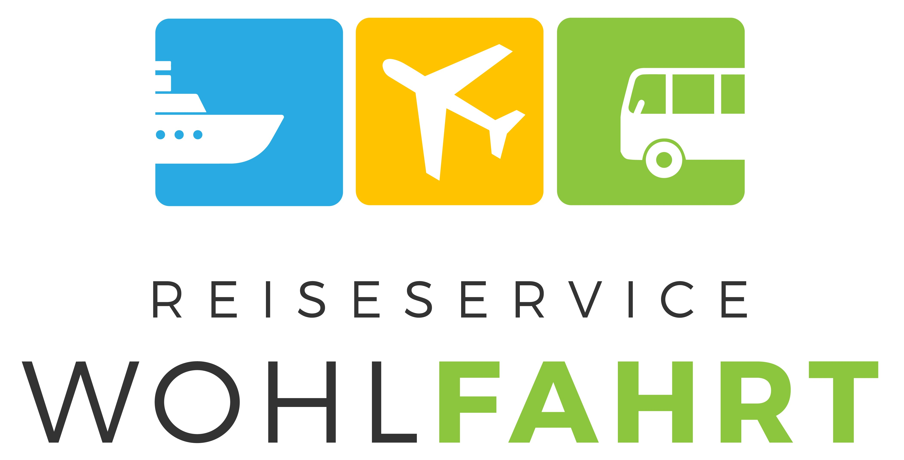
PROGRAM
Weimar and Dessau
Constructor University Bremen
Fall Semester – This trip usually takes place the 2nd or 3rd weekend of October

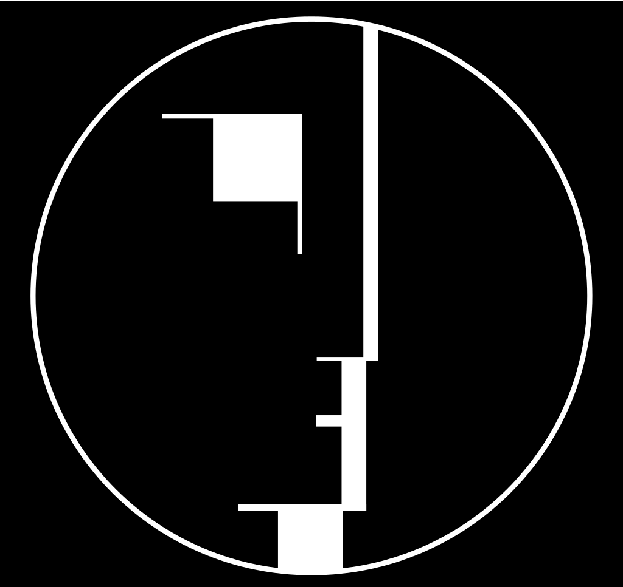
Friday - Day 1

06:45 Meeting at the main gate, Constructor University

07:00 Departure

13:00 Arrival at Weimar

13:45 Guided tour through Bauhaus-Museum (60 minutes)

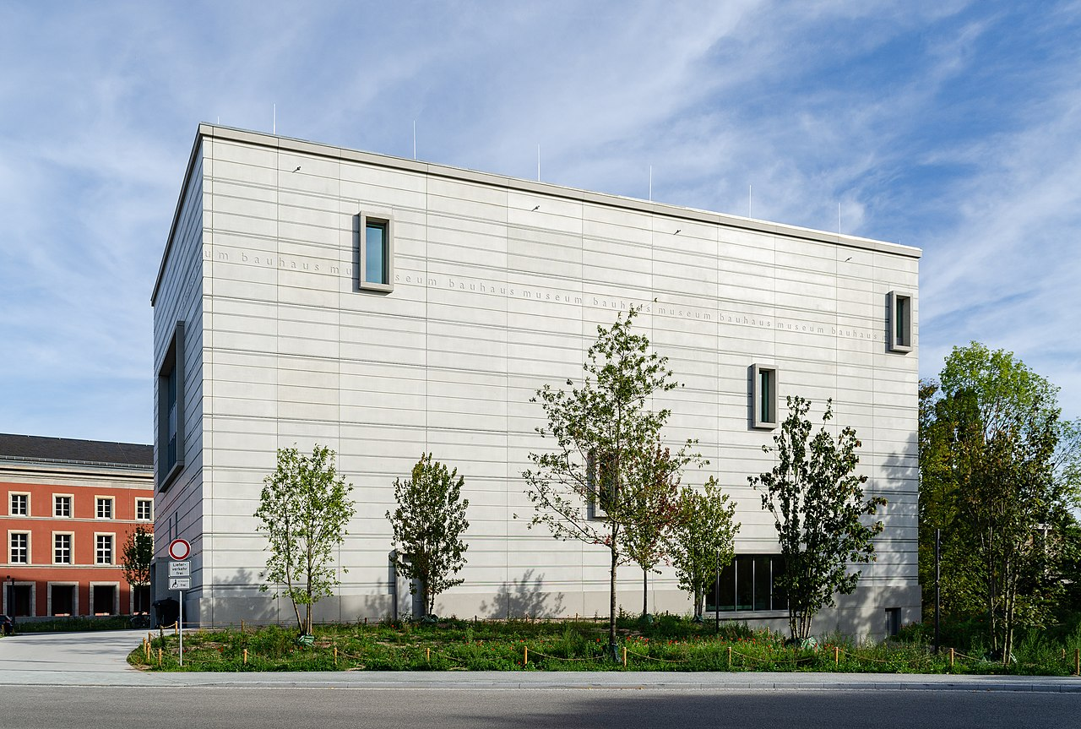

15:30 Visitation Haus Am Horn

16:30 Bauhaus Walk (1,5 hour)

18:00 Departure to Jena

18:30 Check-in to accommodation / Leisure time

Saturday - Day 2

07:00 Breakfast

09:30 Departure to Dessau

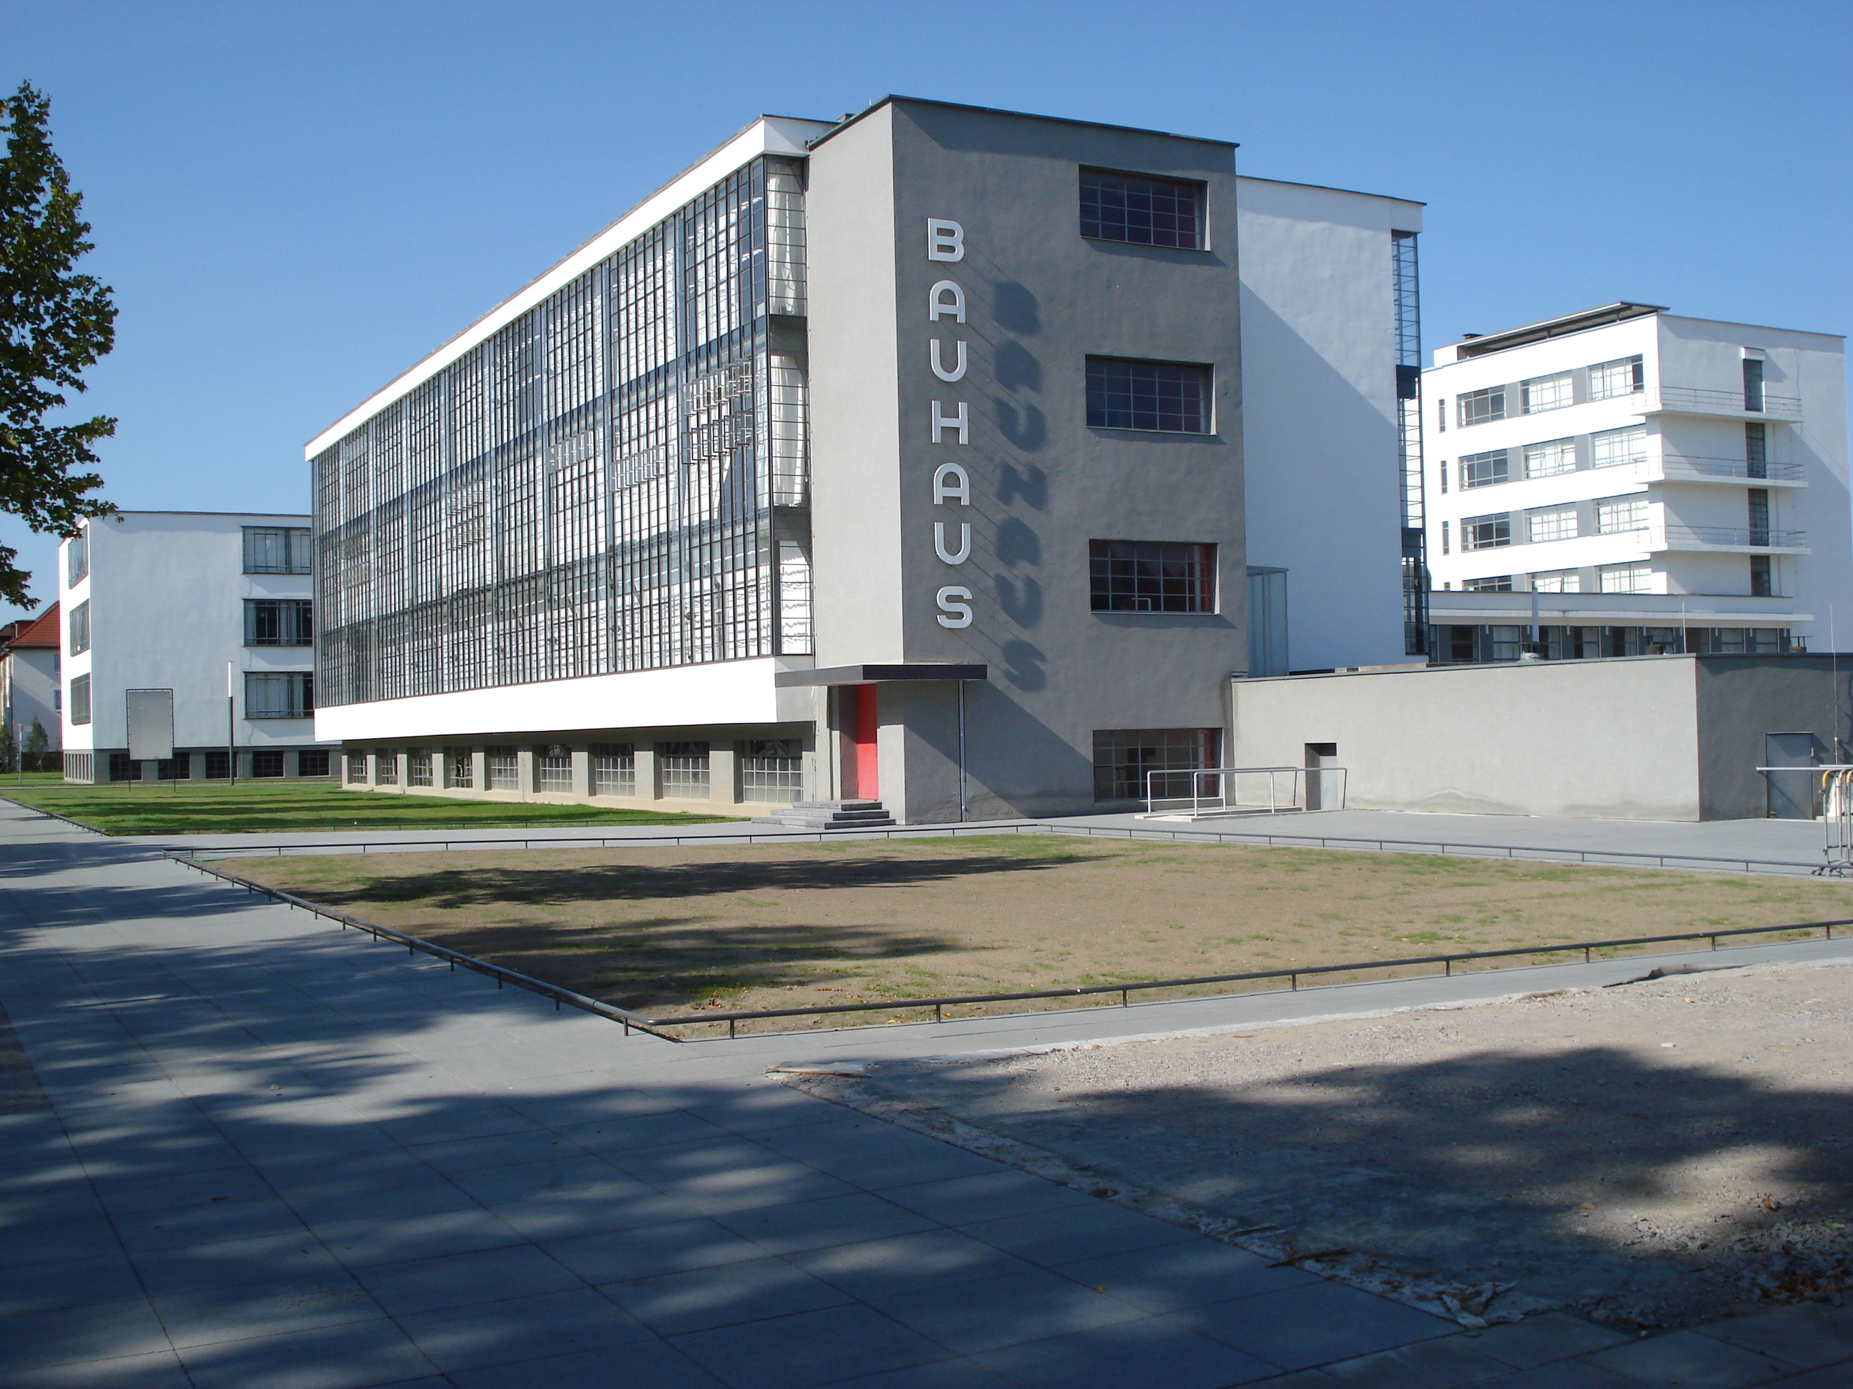

12:00 Arrival at Bauhaus Dessau

12:30 Guided tour through Bauhaus Dessau (1 hour)

14:00 Visitation Meisterhäuser

16:00 Guided tour through Bauhaus Museum Dessau (1 hour)

17:30 Check-in to accommodation in Dessau / Leisure time

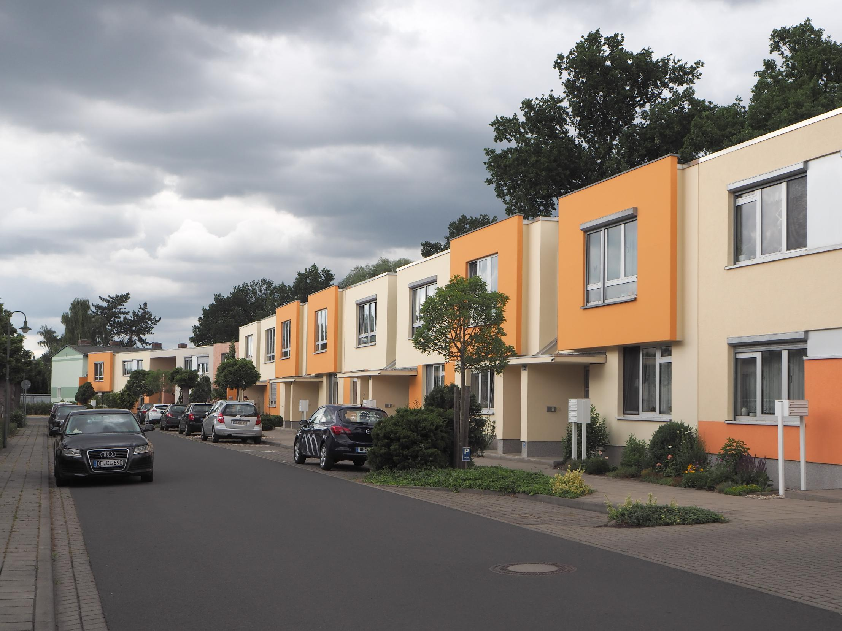

Sunday - Day 3

07:00 Breakfast

09:30 Check-out hotel

09:45 Departure to Bauhaus colony Dessau-Törten

10:15 Guided tour through Bauhaus colony Dessau-Törten (1,5 hour)

13:00 Departure to Bremen

18:00 Arrival in Bremen

